**CLOSED LOOP CONTROL FOR A BRUSHLESS DC MOTOR TO RUN AT THE EXACTLY ENTERED SPEED**

**ABSTRACT**

The project is designed to control the speed of a BLDC motor using closed loop control technique. BLDC motor has various application used in industries like in drilling, lathes, spinning, elevators, electric bikes etc. The speed control of the DC motors is very essential. This proposed system provides a very precise and effective speed control system. The user can enter the desired speed and the motor will run at that exact speed.

Based on the principle of PWM speed can be controlled. This is achieved by keeping BLDC motor on closed loop feedback by giving RPM reference to the microcontroller upon a shaft mounted IR reflection arrangement. An LCD duly interfaced to the microcontroller to display the running speed. The desired speed in percentage of full speed is fed with the help of keypad. The controller delivers desired pulse width to automatically adjust the DC power to the motor for required speed. The above operation is carried out by using one opto-isolator and a MOSFET for driving the BLDC motor with IR sensing for getting the speed reference to the microcontroller.

Further the project can be enhanced to a fully fledged fuzzy logic control of a BLDC motor for industrial applications. It can also be developed for an intelligent cruise control used in modern automobiles these days.

BLOCK DIAGRAM

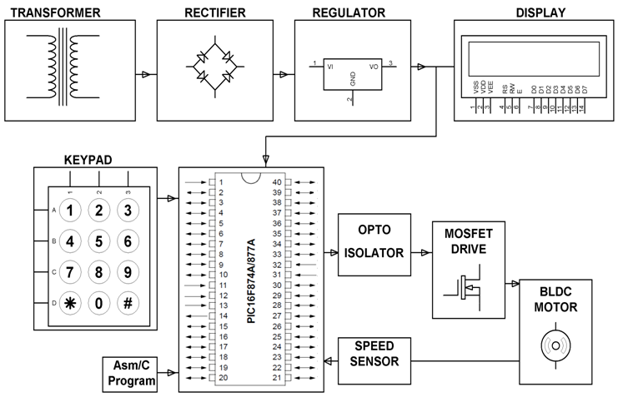

**HARDWARE REQUIREMENTS:**

PIC series Microcontroller, MOSFET, LCD, Transformer, Voltage Regulator, Capacitors, Resistors, Diodes, Keypad, Opto-Isolators, BLDC Fan, IR and Photo Diode.

**SOFTWARE REQUIREMENTS:**

HI-TECH PICC Tool suite

Languages: Embedded C or Assembly